**Indian Institute of Management, Ahmedabad**

**Accelerated General Management Programme - 2020**

**Managerial Computing Exam**

**17th May 2020 Time: 2 hours**

**Instructions**

1. Open Book exam
2. Please fill both doc and spreadsheet
3. Submit both the files on Moodle.

**Question 1 (22 points)**

We are given the following monthly data concerning Ahmedabad’s weather in Range **A3:E15** (Refer Excel Sheet-1). Answer the following questions concerning this data.

1. Write a formula for cell B18 to find highest precip. **(2 points)**

**B18**: = =MAX(E4:E15)

1. Write a formula for cell B19 to find the month with the highest precip. **(6 points)**

**B19**: = INDEX(A4:A15,MATCH(B18,E4:E15,0))

1. Write a formula for cell B20 to obtain the high temperature for the month with the highest precipitation (month in cell B19). **(4 points)**

**B20**: = INDEX(A4:E15,7,2)

1. Write a formula in B22, to calculate the number of months with precip more than 100. You can use cells D21 and D22 for the criteria range. **(6 points)**

**D21**: >100 **D22**:

**B22**: COUNTIF(E4:E15, ">100")

1. Months in which the high temperature exceeds 38 degrees Celsius, OR in which the low is less than 14 degrees Celsius have a high probability of school holidays. We use the advanced filter option to find all months which have a high probability of a holiday. These need to be listed in cells A24 onwards**.** You can use the range C24 to D26 for the criteria to be used for the advanced filter. Fill in the contents for the following cells to be used for the criteria:

**(4 points)**

**C24**: high **D24**: low

**C25**: >38 **D25**: -

**C26**: - **D26**: <14

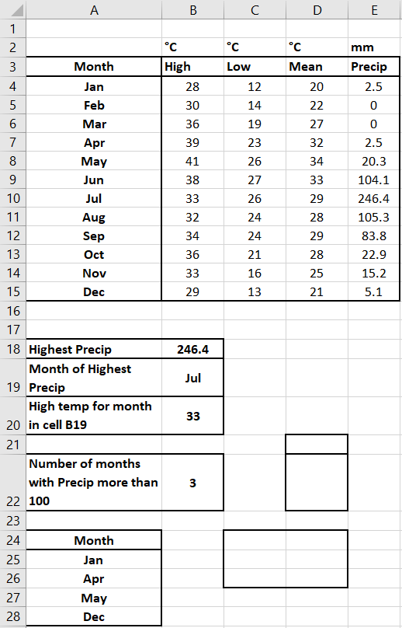

**Question 2** (Refer Excel Sheet-2)**: (8 points)**

An institute generates student Ids as 9 characters, where the first 4 characters are the year, then the next two are the stream code, and last 3 are the serial number.

**Example** : 1994C3365 = 1994 & C3 & 365

It wants to change the stream code to a more meaningful new system as given in Table 1, for example C3 will change to HM and new id will be 1994HM365.

This is done in 3 steps as shown in the spreadsheet.

**Step 1**: The old stream code is extracted . Write a formula in cell C4 which will be copied downwards, to do this.

**Formula in C4**:

= MID(B4,5,2)

**Step 2**: In D4, find the new stream code corresponding to the old stream code in C4.

Again, this formula will be copied downwards.

**Formula in D4**:

=VLOOKUP(C4,$I$3:$J$11,2,0)

**Step 3**: Generate the new Id in cell E4

**Formula in E4**:

= REPLACE(B4,5,2,D4)

